Aim
To implement a basic CI/CD pipeline using Git, GitHub, GitHub Actions, and Maven that automatically builds a Java application and stores the generated JAR file as a GitHub artifact/release.

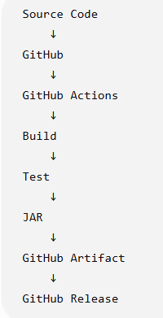
Software Required
- Windows 10/11
- Git
- Web browser
- VS Code
- GitHub account
Java and Maven do not need to be installed on Windows.

Step 1— Configure Git
Enter your name:
git config --global user.name "Your Name"
Enter your email:
git config --global user.email "your-email@example.com"
Verify:
git config --global --list

Step 2 — Create a Simple Java Project
Create a folder on the Desktop:
GitHub-CICD-Demo
Create the following structure:
GitHub-CICD-Demo
│
├── src
│ └── main
│ └── java
│ └── App.java
│
├── pom.xml
└── .gitignore

pom.xml
<project xmlns="http://maven.apache.org/POM/4.0.0"
xmlns:xsi="http://www.w3.org/2001/XMLSchema-instance"
xsi:schemaLocation="http://maven.apache.org/POM/4.0.0
https://maven.apache.org/xsd/maven-4.0.0.xsd">

<modelVersion>4.0.0</modelVersion>

<groupId>com.example</groupId>
<artifactId>github-cicd-demo</artifactId>
<version>1.0</version>

<properties>
<maven.compiler.source>21</maven.compiler.source>
<maven.compiler.target>21</maven.compiler.target>
</properties>

</project>

.gitignore
target/

Step 3 — Initialize Git
Open Git Bash in the project folder.
cd Desktop/GitHub-CICD-Demo
Initialize Git:
git init
Check:
git status

Step 4— Add the Files
git add .
Check:
git status
You should see:
App.java
pom.xml
.gitignore

Step 5— Commit the Project
git commit -m "Initial Java application"

step 6 — Create GitHub Repository
Go to:
GitHub
Click:
New repository
Enter:
github-cicd-demo
Click:
Create repository

Step 7 — Connect Local Repository to GitHub
GitHub will show a repository URL.
Use:
git remote add origin https://github.com/YOUR_USERNAME/github-cicd-demo.git

git push -u origin master

Step 8— Create GitHub Actions Workflow
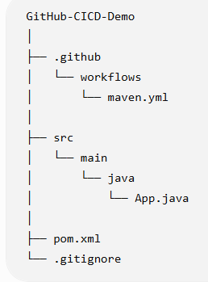

Step 9 — Write the GitHub Actions Workflow
Put this inside maven.yml:
name: Java CI with Maven
on:
push:
branches: [ "master" ]
pull_request:
branches: [ "master" ]
jobs:
build:

runs-on: ubuntu-latest

steps:
- uses: actions/checkout@v5
- name: Set up JDK 21
uses: actions/setup-java@v5
with:
java-version: '21'
distribution: 'temurin'
cache: maven
- name: Build with Maven
run: mvn -B package --file pom.xml

- name: Upload JAR file
uses: actions/upload-artifact@v6
with:
name: maven-jar
path: target/*.jar

Step 10 — Commit the Workflow
Go back to Git Bash:
git add .
Commit:
git commit -m "Add GitHub Actions pipeline"
Push:
git push

Step 11 — Open GitHub Actions
Go to your GitHub repository.
Click:
Actions
You should see:
Java CI/CD
Click the workflow.
You will see:
Checkout source code ✓
Set up Java ✓
Build and package ✓
Upload JAR file ✓
If all are green:
CI pipeline completed successfully.

Step 12 — Find the JAR
Click the completed workflow run.
At the bottom, find:
Artifacts
You should see:
github-java-application
Click it.
Download the ZIP.
Inside the ZIP:
github-cicd-demo-1.0.jar

Step 13 — Create a GitHub Release
For a more complete release/deployment exercise:
Go to:
GitHub → Releases → Create a new release
Create a tag:
v1.0
Title:
Java Application v1.0
Download the JAR artifact from the Actions run and attach the JAR to the release.

Result: The GitHub Actions CI pipeline was successfully configured. Whenever the source code was pushed to the GitHub repository, the workflow was automatically triggered and the Maven project was successfully built. The build status was verified as successful in the GitHub Actions tab.

